Quick Reference Guide – External Record Search

- The external records tab is located across the top in the clinical portal
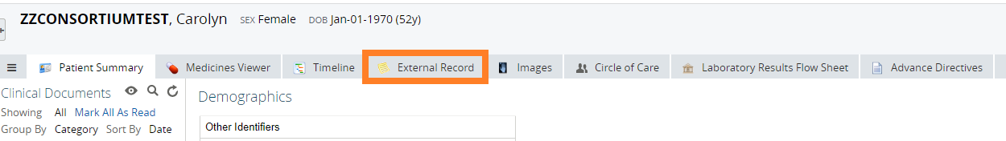
- Press the “Add” button to add a specific external location to query for records.
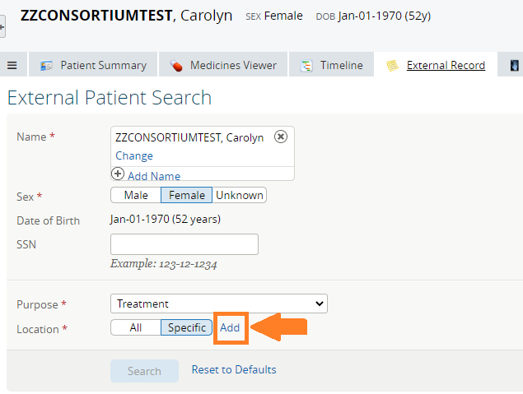

- Highlight the desired external location (in this example, Mayo Clinic), then press the right arrow to move the external location to the “Selected Locations” window on the right.
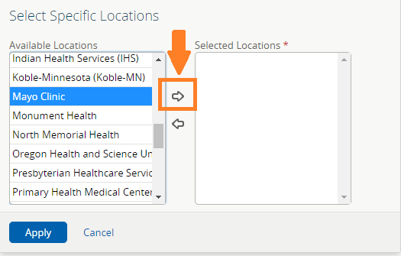

- Once complete, this Select Specific Dialogue box should look like this. You may add additional external locations through the same process. Once complete, press “Apply” on the bottom left.
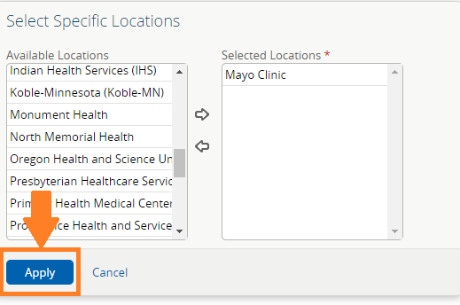

- The selected external locations will appear as individual buttons to the right of the location selection tool. Once satisfied, press the Search button to initiate the search.
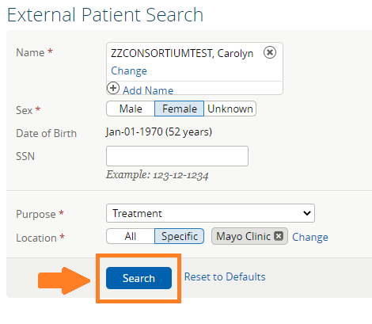

More information on next page.

- Search results are displayed below the search button. While the query is running you will see a spinning icon near the search location to indicate the search is in progress. This icon will be replaced with patient demographics when the search is finished. Click on “View External Documents” to bring up the available external documents.
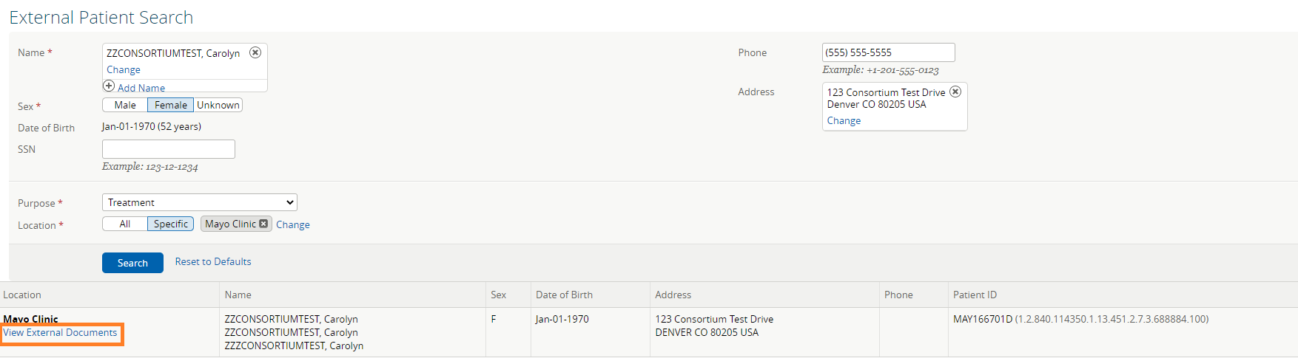

More information on next page.

- External documents are displayed on the left side of the window in a document tree. Click the arrow expand the tree down and then on individual documents to view them on the right. When complete, you may use the navigation tabs at the top of the screen to view local NDHIN information on the selected patient.
