Click the above link to open the NDHIN Authorized User Agreement electronic form. You will receive an email once your user account is created.

When you are asked to assign the NEXT PARTICIPANT, enter:
{First Name Last Name Email}
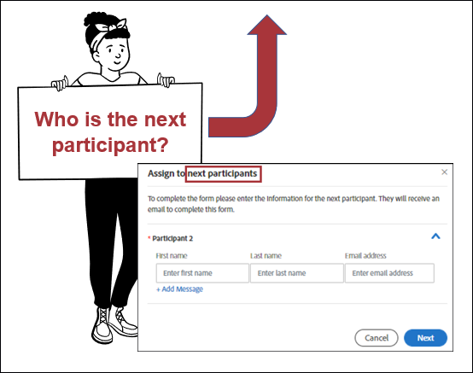
Please remember: As an authorized user of the North Dakota Health Information Network (NDHIN) Clinical Portal you have agreed to access only the patients and patient data that is necessary to do your job. Additionally, NDHIN policy states: NDHIN shall limit the right of an Individual to access their own PHI or that of a family member. Additional information on NDHIN policies can be found at https://www.ndhin.nd.gov/about-us/ndhin-policies.

